You want to build n new buildings in a city. The new buildings will be built in a line and are labeled from 1 to n.

However, there are city restrictions on the heights of the new buildings:

* The height of each building must be a non-negative integer.
* The height of the first building **must** be 0.
* The height difference between any two adjacent buildings **cannot exceed** 1.

Additionally, there are city restrictions on the maximum height of specific buildings. These restrictions are given as a 2D integer array restrictions where restrictions[i] = [idi, maxHeighti] indicates that building idi must have a height **less than or equal to** maxHeighti.

It is guaranteed that each building will appear **at most once** in restrictions, and building 1 will **not** be in restrictions.

Return *the* ***maximum possible height*** *of the* ***tallest*** *building*.

**Example 1:**

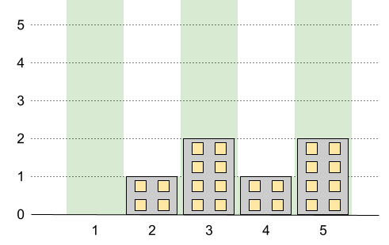

Input: n = 5, restrictions = [[2,1],[4,1]]  
Output: 2  
Explanation: The green area in the image indicates the maximum allowed height for each building.  
We can build the buildings with heights [0,1,2,1,2], and the tallest building has a height of 2.

**Example 2:**

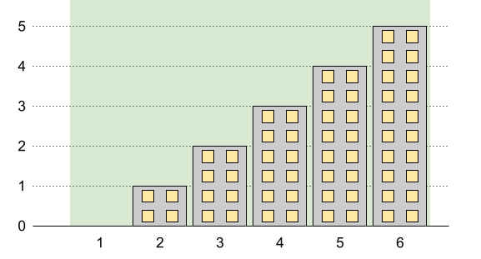

Input: n = 6, restrictions = []  
Output: 5  
Explanation: The green area in the image indicates the maximum allowed height for each building.  
We can build the buildings with heights [0,1,2,3,4,5], and the tallest building has a height of 5.

**Example 3:**

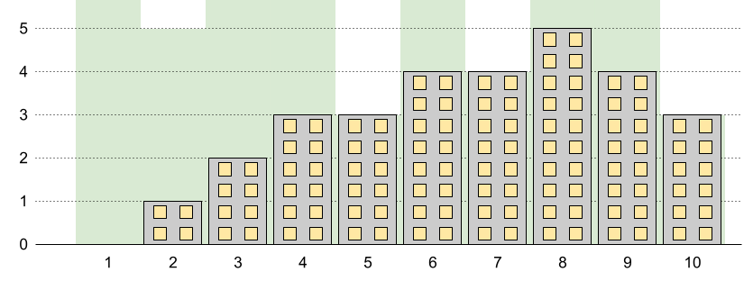

Input: n = 10, restrictions = [[5,3],[2,5],[7,4],[10,3]]  
Output: 5  
Explanation: The green area in the image indicates the maximum allowed height for each building.  
We can build the buildings with heights [0,1,2,3,3,4,4,5,4,3], and the tallest building has a height of 5.

**Constraints:**

* 2 <= n <= 109
* 0 <= restrictions.length <= min(n - 1, 105)
* 2 <= idi <= n
* idi is **unique**.
* 0 <= maxHeighti <= 109